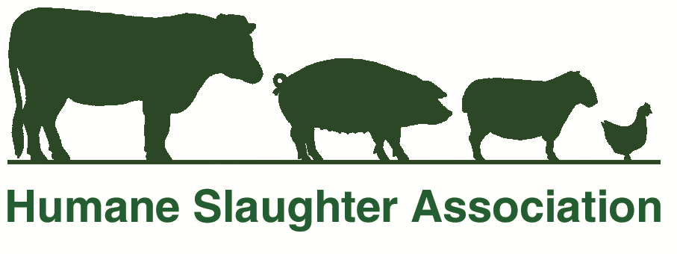

Media Release

9th February, 2015
For Immediate Release:

HSA Announces Programme for International Symposium

The Humane Slaughter Association (HSA) has published the full programme of speakers for the upcoming HSA International Symposium being held in Zagreb, Croatia, in July. There will be 31 presentations over the two-day event, covering a wide range of topics relevant to the welfare of food animals during transport, marketing and slaughter or killing.

The programme includes Prof Malcolm Mitchell (SRUC, UK) ‘The effects of journey time upon the welfare of pigs in transit: A study under commercial transport conditions’, Dr JW van de Vis (IMARES, The Netherlands) ‘An approach to implement stunning and killing of fish’ and Dr Alison Small (CSIRO, Australia) ‘DTS: Diathermic syncope for cattle stunning’. They join Prof Suzanne Millman (Iowa State University, USA), Dr Karen von Holleben (bsi Schwarzenbek, Germany), Steve Wotton (University of Bristol, UK) and Vasco Antunes (European Commission Food and Veterinary Office, Ireland) amongst other eminent speakers.

Keynote speakers announced previously include Prof Yvonne Vizzier Thaxton (University of Arkansas, USA) ‘From Idea to Reality: The Development of the Low Atmosphere Stunning System’ and Dr Mara Miele (Cardiff University, UK) ‘Making slaughter of livestock acceptable to the consumer: how science, technology and religion affect the public debate about slaughtering practices’.

The full programme, and further details about the HSA International Symposium 2015, can be found at www.hsa.org.uk/internationalsymposium

-ENDS-

Media contact:
Charles Mason, HSA Technical Director. Tel: 01582 831919,
Email charlie@hsa.org.uk

Note to Editors:

The HSA is an independent charity recognised internationally for promoting scientific,
technical and educational advances towards improving the welfare of food animals
worldwide at slaughter, killing, marketing and transport.

Its work includes researching, refining and demonstrating humane slaughter methods,
publishing material such as guidelines, best practice, books and videos, funding research
projects and the development of equipment. Specialist technical staff provide expert and
practical advice on all welfare issues relating to food animals.

The HSA is funded by voluntary donations, subscriptions and legacies.

For more information about the HSA’s work call 01582 831919, email info@hsa.org.uk or
visit www.hsa.org.uk

The Humane Slaughter Association
The Old School, Brewhouse Hill
Wheathampstead,
St Albans, Herts. AL4 8AN
Tel: 01582 831919
Fax: 01582 831414
Email: info@hsa.org.uk
www.hsa.org.uk

Humane Slaughter Association and Council of Justice to Animals
Registered in England Charity No: 209563

